Tabel 1.2 Statistik Deskriktif
 | N | Minimum | Maximum | Mean | Std. Deviation
Y1 | 190 | 1 | 3 | 2.69 | .576
X1 | 190 | 1 | 3 | 1.82 | .415
X2 | 190 | 1 | 3 | 2.18 | .415
lama_bekerja | 190 | 0 | 20 | 4.67 | 2.499
Umur | 190 | 18 | 47 | 29.54 | 6.515
Valid N (listwise) | 190

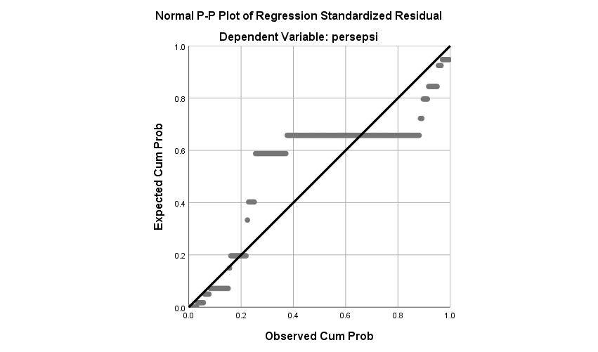
Model |  | Sig. | Collinearity Statistics
 |  | Sig. | Tolerance | VIF
1 | (Constant) | .000
1 | shift jaga | .000 | 1.000 | 1.000
1 | lalu-lintas KA | .296 | 1.000 | 1.000
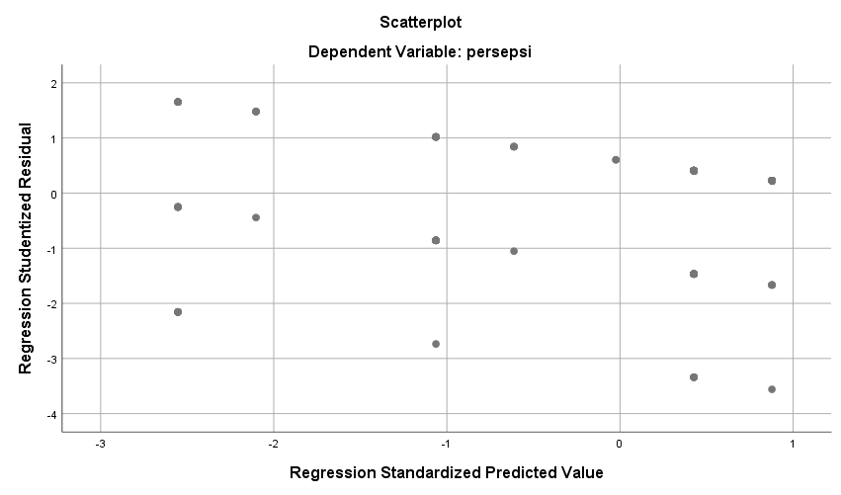

Model | R | R Square | Adjusted R Square | Std. Error of the Estimate | Durbin-Watson
1 | .379ª | .144 | .134 | .536 | 2.062
a. Predictors: (Constant), lalu-lintas KA, shift jaga
b. Dependent Variable: persepsi

Model |  | Sig. | Collinearity Statistics
 |  | Sig. | Tolerance | VIF
1 | (Constant) | .000
1 | shift jaga | .000 | 1.000 | 1.000
1 | lalu-lintas KA | .296 | 1.000 | 1.000

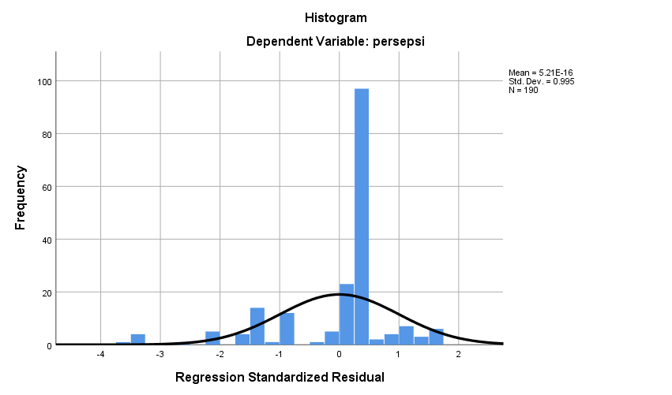
Model |  | Sum of Squares | df | Mean Square | F | Sig.
1 | Regression | 9.003 | 2 | 4.502 | 15.683 | .000^{b}
1 | Residual | 53.676 | 187 | .287
1 | Total | 62.679 | 189
a. Dependent Variable: persepsi
b. Predictors: (Constant), lalu-lintas KA, shift jaga

Model Summary^{b}
Model | R | R Square | Adjusted R Square | Std. Error of the Estimate | Durbin-Watson
1 | .379ª | .144 | .134 | .536 | 2.062
a. Predictors: (Constant), lalu-lintas KA, shift jaga
b. Dependent Variable: persepsi

